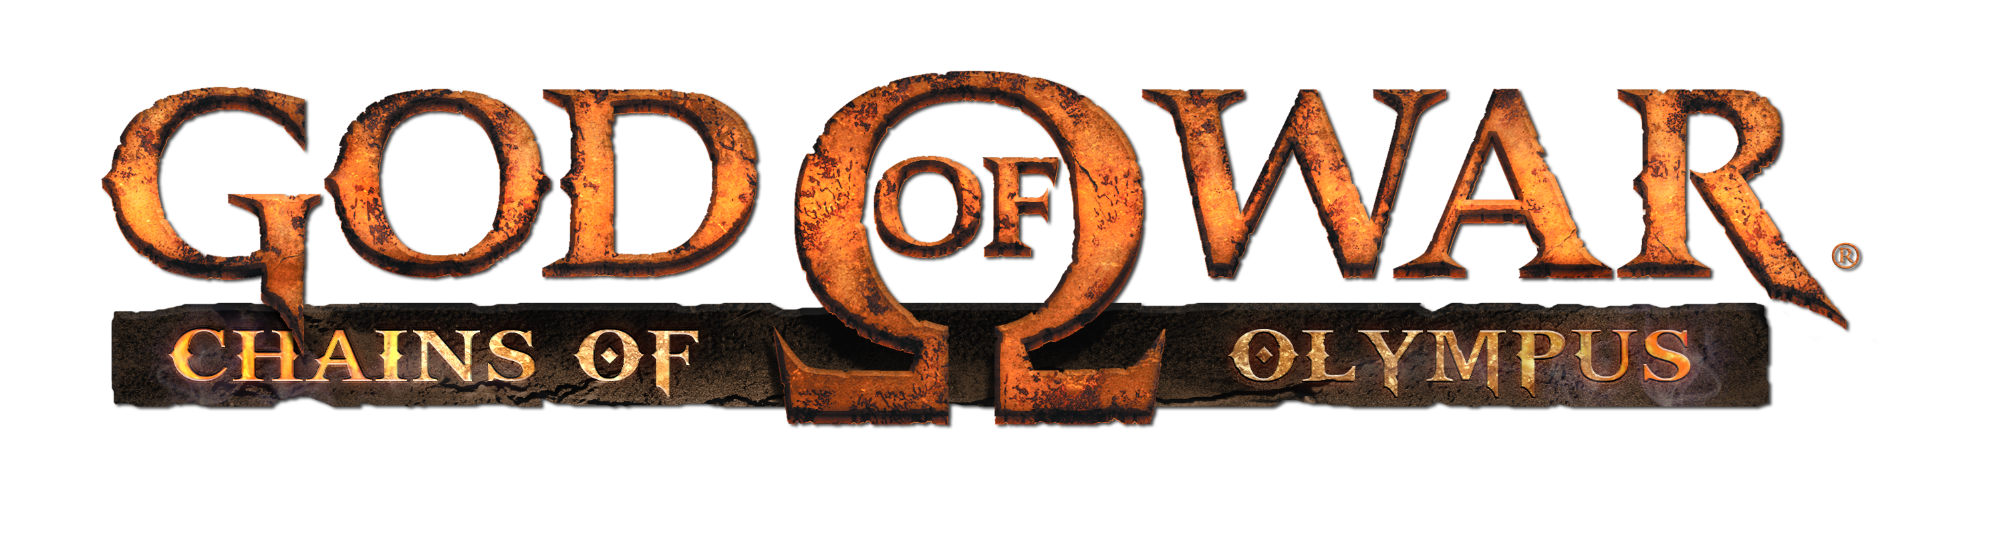

Press Information
For Immediate Release

God of War®: Chains of Olympus set for showcase at Leipzig

- First God of War title for PSP™ to go on show at Leipzig Games Convention
- Set prior to 2005’s God of War® – learn more about Kratos’ brutal past
- Title features new enemies and quests with the carnage that Kratos fans love

Leipzig, Germany, August 20-22: This year’s Leipzig Games Convention will see Sony Computer Entertainment Europe offer a glimpse of things to come for the fearsome anti-hero Kratos when he makes the leap to PSP™ (PlayStation®Portable) in God of War®: Chains of Olympus in early 2008. Developed from the outset as an original story set prior to the award-winning God of War® on PlayStation®2, this new title will see Kratos face the most feared creatures from Greek Mythology and as he journeys to lands that no mortal has ever walked upon.

The story of God of War: Chains of Olympus takes place after Kratos is deceived into killing his own wife and children by Ares. Renouncing Ares and now known as the ‘Ghost of Sparta’, he enters the service of the other Olympian Gods seeking absolution from his sins. The game itself begins with a desperate defence of Attica against the might of the Persian army.

The first PSP™ God of War title keeps true to the God of War ethos with epic set pieces, dramatic camera angles, highly-detailed graphics, incredible animation detail and the entire heritage of this award-winning, world-conquering series – a truly worthy addition to the God of War franchise and a brutal tale of action, and vengeance. The Blades of Chaos are in your hands once again – and this time you can battle gods and monsters wherever you like, thanks to the portable power of PSP™.

- A dark and intense journey that will take you from the Gates of Hades to the Depths of Tartarus; set during Kratos’s ten years of servitude to the Gods of Olympus.

- Wield the Chains of Olympus again – with all-new combat moves to use alongside your favourite combination attacks from the God of War franchise.

- Face-off against all new creatures from Greek Mythology, engage in epic boss battles and navigate a labyrinth of challenging puzzles inter-woven into the story.

- God of War: Chains of Olympus is brought to you by two award-winning development teams, Sony Computer Entertainment America’s Santa Monica Studios and Ready At Dawn Studios.
God of War: Chains of Olympus is fast-paced action in the dark and brutal word of Greek Mythology – and it’s at this year’s Leipzig Games Conference prior to its release exclusively on PSP™ in early 2008.
ENDS

For more information, please contact your local PR Manager.

About Sony Computer Entertainment Europe Ltd. As at 16 May 2007

Sony Computer Entertainment Europe (SCEE), based in London, is responsible for the distribution, marketing and sales of PLAYSTATION®3, PlayStation®2 and PSP® (PlayStation®Portable) software and hardware in 102 territories across Europe, the Middle East, Africa and Oceania. SCEE also develops, publishes, markets and distributes entertainment software for these formats, and manages the third party licensing programs for the formats in these territories. Between its European debut on 24th November 2000 and the end of March 2007, over 44 million PlayStation 2 consoles have been shipped across the SCEE territories, over 117 million worldwide, making it one of the most successful consumer electronic products in history. Between its European debut on 1st September 2005 and the end of March 2007, over 8 million PSP systems have been shipped across the SCEE territories, with over 25 million shipped worldwide since its Japanese launch in December 2004. Between its European debut on 23rd March 2007 and the end of March 2007, over 1.5 million PS3 systems have been shipped across the SCEE territories, with over 5.5 million shipped worldwide since its Japanese launch in November 2006.

About Ready At Dawn

Founded in 2003, Ready At Dawn Studios LLC is a creator of cutting-edge console videogames based in Santa Ana, California. More information about the company can be found on the company's World Wide Web site, which is located at www.readyatdawn.com.

